Web Soil Survey Tutorial
Did you know there are handy FREE tools available on the web to help you locate soil information? Why is this important? By knowing your soil type, you will be well prepared when it comes to building a home or other structure; if you are looking at tillable farm land you can utilize soil information to understand each drainage type, and predict potential crop yields. Knowing how to utilize Web Soil Survey will be able to assist you in numerous situations.
The most commonly used resources are:
- USDA-Web Soils Survey (WSS)
- Google Earth
- County Auditor’s office (if available)
- Local Soil and Water Conservation District Office
We are going to focus on Web Soil Survey (WSS).
To get started click on the button.
At the top of the next screen you will see 5 tabs at the top of the screen and a panel on the left side of the page. You will want to make sure that the 1st tab is selected and will read “Area of Interest/AOI.” 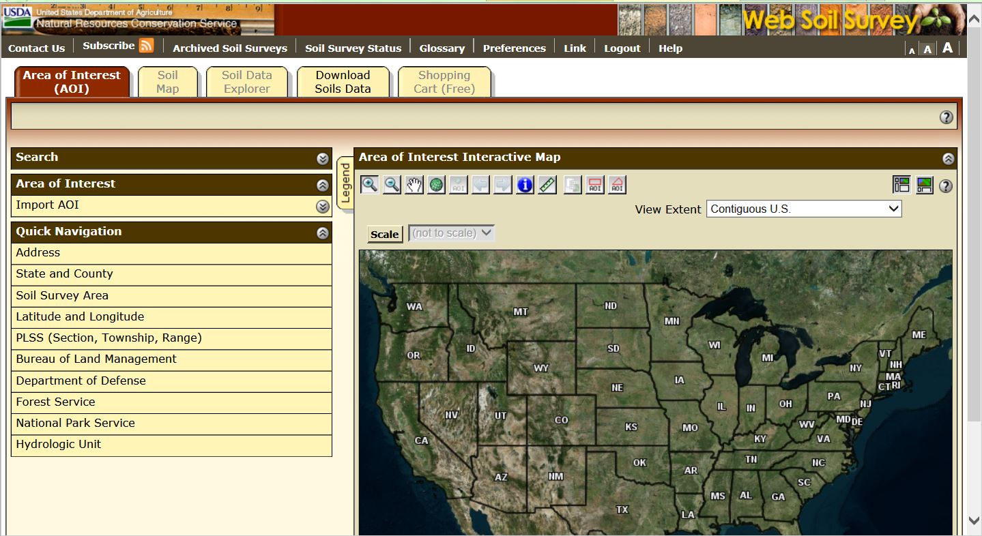
Once you have entered in a specific location, your map you should have changed and the area shown should be recognizable.
Before we go any further, you should become comfortable with a couple options the program offers. First is the “full screen” option. You will find this in the upper right hand corner of your screen, it looks like this.
Next you will need to become comfortable with the toolbar.
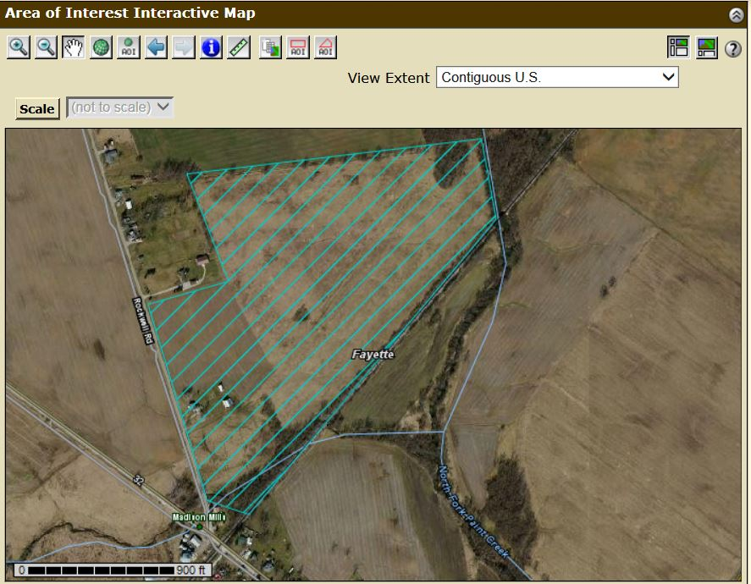
It may look intimidating, but it’s really quite easy when you get used to it. There are only 4 buttons you will need to use to obtain a soils map of the selected area. I want to talk about the 3rd button first. This button is the “pan” button and you will use this function to move around the screen to find your exact location. Everyone is familiar with the 1st and 2nd buttons on the toolbar (zoom out and zoom in). When using web soil survey this feature is a little different. In order to zoom in or out you will need to drag your cursor over the selected area. While doing this you should see a box cover the selected area, once you release your cursor the image on the map will refocus. Once you have “panned” and “zoomed to” your desired location it is now time to determine you’re “Area of Interest” and use the last button on the tool bar that we will discuss. The very last button on the tool bar is your “AOI” button, this is the polygon feature. By using the polygon feature you are able to make numerous points around a location. This helps when property and field boarders aren’t perfectly square. To close or end your polygon “double-click” on the last point made. Below is an example of a property I have used the polygon function on to determine soils.
Once the “Area of Interest” has been created, you will need to change tabs at the top of your screen to “Soil Map.” Once you have your soil map you can either print a copy or click on the option “Add to Shopping Cart.”
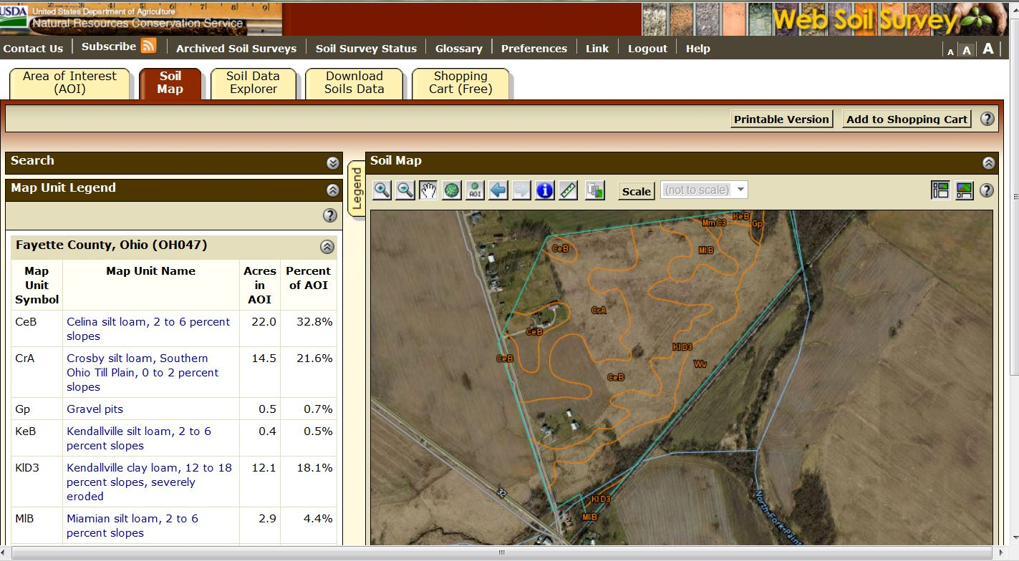
You will notice that a list of soil types specific to your AOI are now available on the left side of your screen. You can “double-click” on an individual soil type and a description box will pop out.
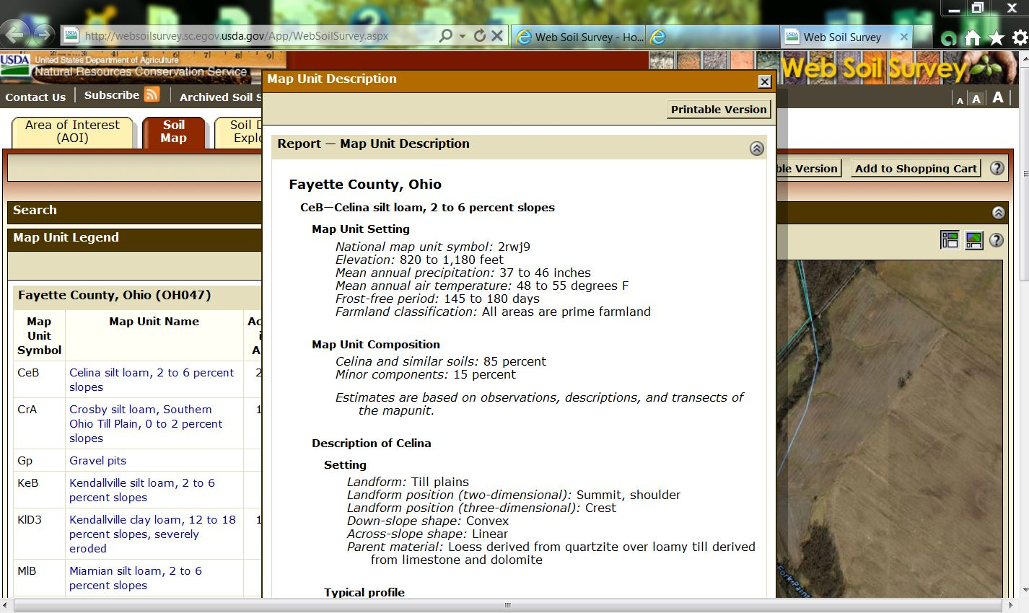
The next tab at the top of the screen is labeled “Soil Data Explorer,” click on this next. It will bring a new menu up and you will want to click on the tab “Suitability’s and Limitations Ratings.”
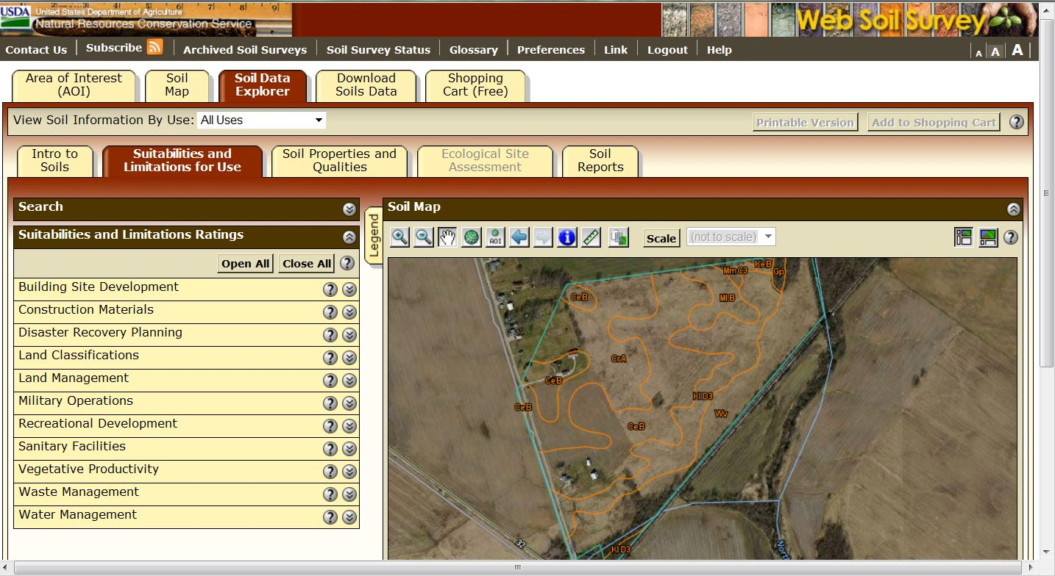

This menu is going to give you information on your specific soil types and what it is suitable for and the limitations it may have.
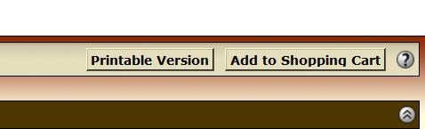
At any point along the process you can print your information or save it. In the upper right hand corner there are two features “printable version” and “add to shopping cart.” If you choose printable version, your maps will print right away. If you add it to the shopping cart you work will be their until you are ready to “Check Out.”
A piece of advice, “this program will time out.” Make sure if you are working on a project to try and finish before you step away to work on something else.
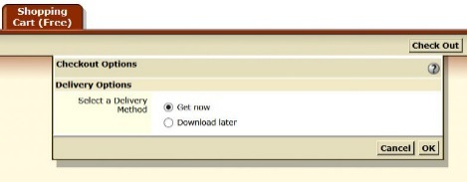
When you go to “Check Out” you will have two options, to either “get it now” or “download later.”
You can choose both “Delivery Methods” and get the same customized soils report.

So here you have it, the down and dirty guide on to how to use Web Soils Survey. There are many other tutorials available on the internet (videos included), but you can always visit your local Soil and Water Conservation District for help.
Thanks!

